Assignment-14.2
Name: T.Harshitha
HT No: 2303A51953
Batch: 22

Description 1 – (Landing Page Design)
• Create a simple landing page for a product or service. Include a
header, hero section, and footer.
Requirements:
• Use HTML and CSS to structure the page.
• Use AI to suggest layout alignment and typography.
• Ensure the page is responsive across devices.

Prompt and code:
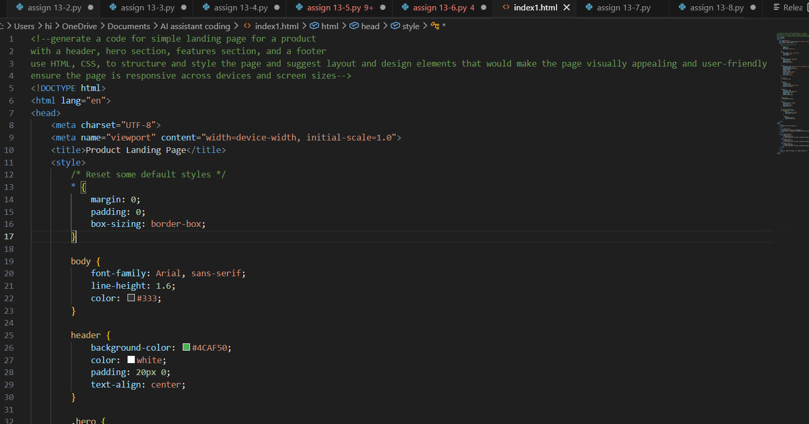
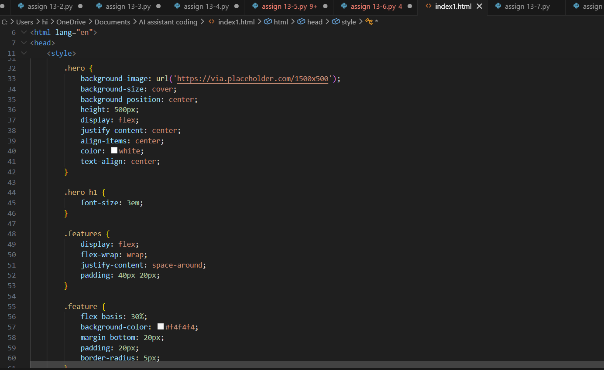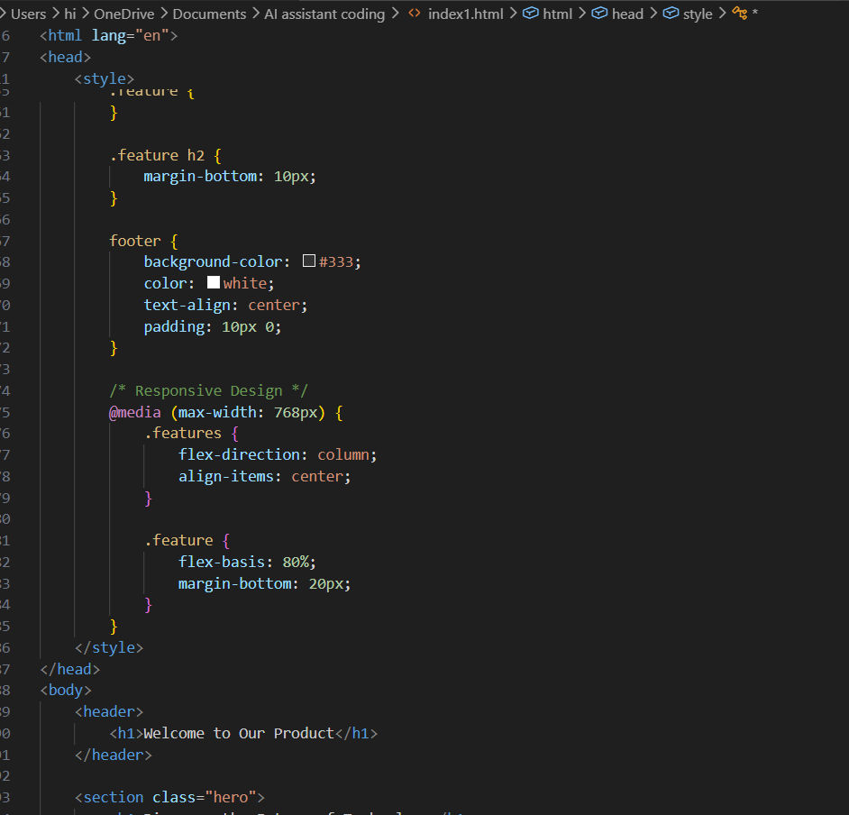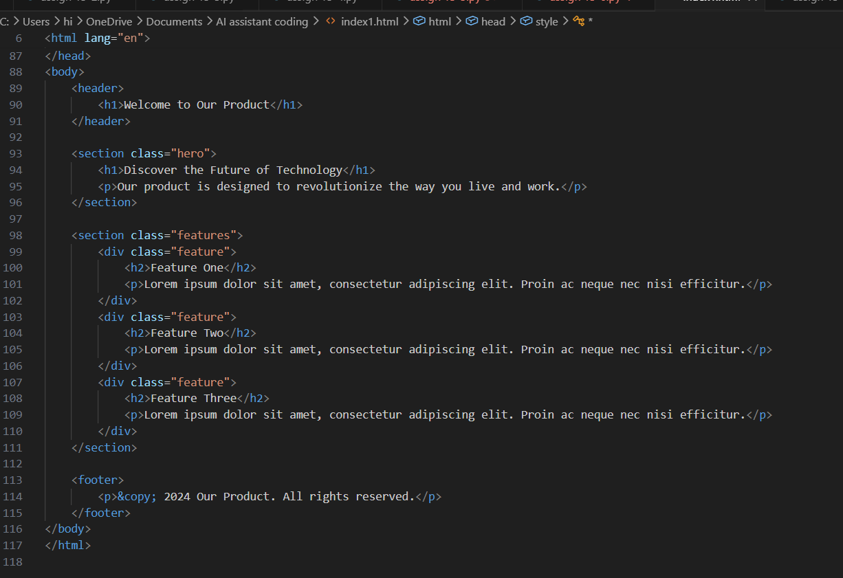

Output:
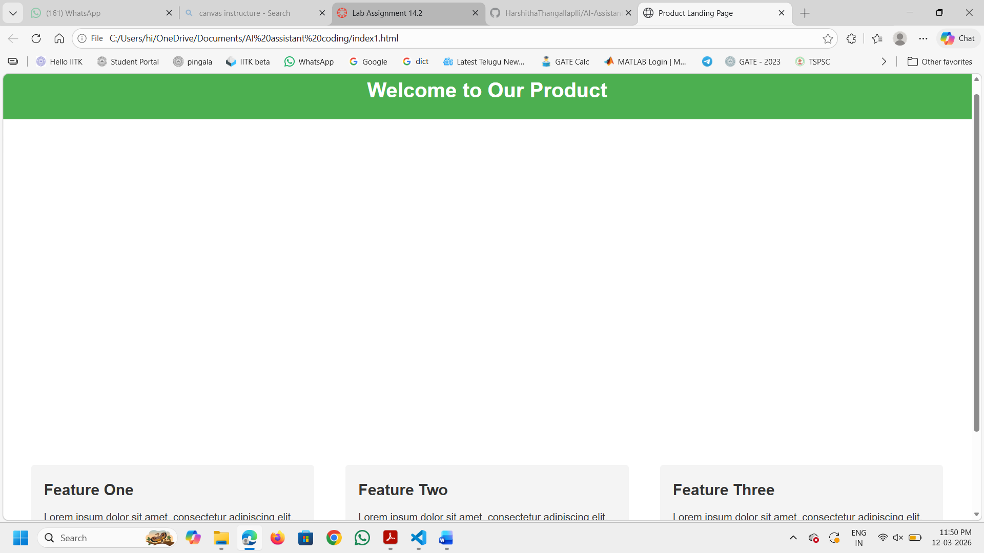
Explanation:
The landing page is structured with a header, hero section, features section, and footer. The header contains the product name and a welcoming message. The hero section features a background image with a headline and a brief description of the product. The features section highlights three key features of the product, each in its own styled box. The footer provides copyright information. The CSS styles ensure that the page is visually appealing and responsive across different devices and screen sizes. The use of flexbox allows for a flexible layout that adapts to various screen widths, making the page user-friendly on both desktop and mobile devices.

Task Description 2 – (Theme Toggle Feature)
• Provide a button to switch between light and dark themes..
Requirements:
• Use JavaScript to toggle CSS classes.
• Use AI assistance to manage color contrast and accessibility.
• Ensure theme preference applies instantly on click.

Prompt and code:
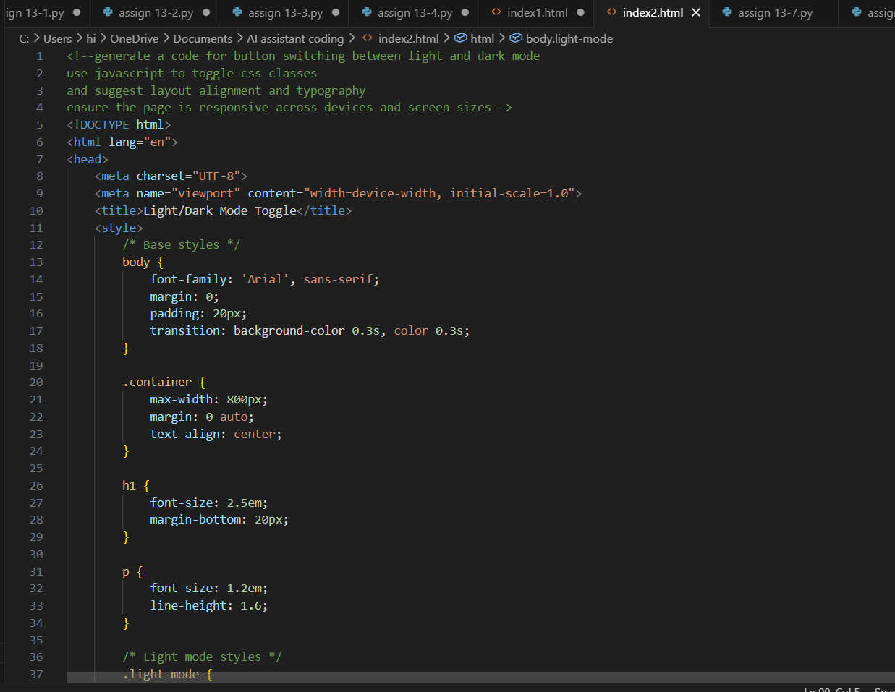
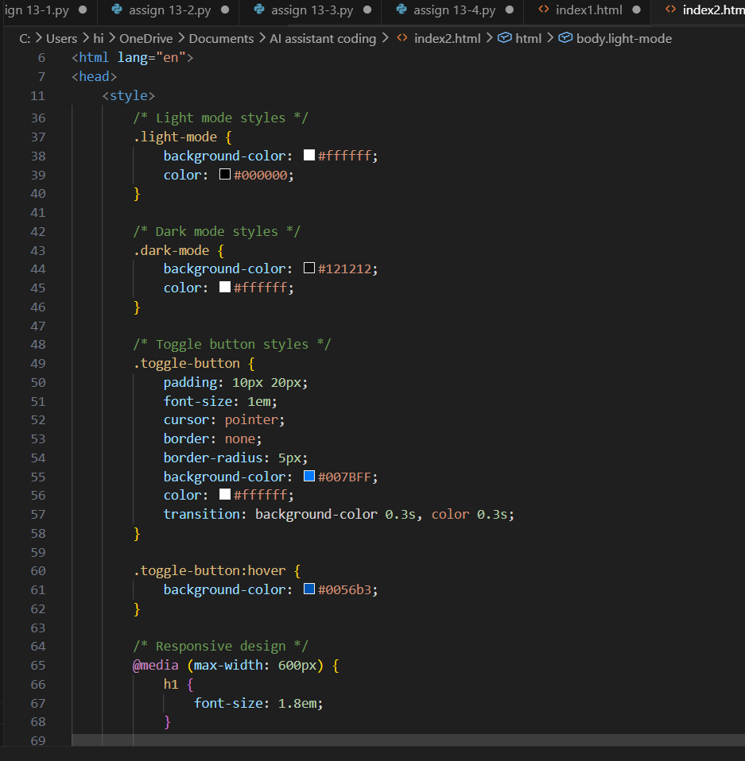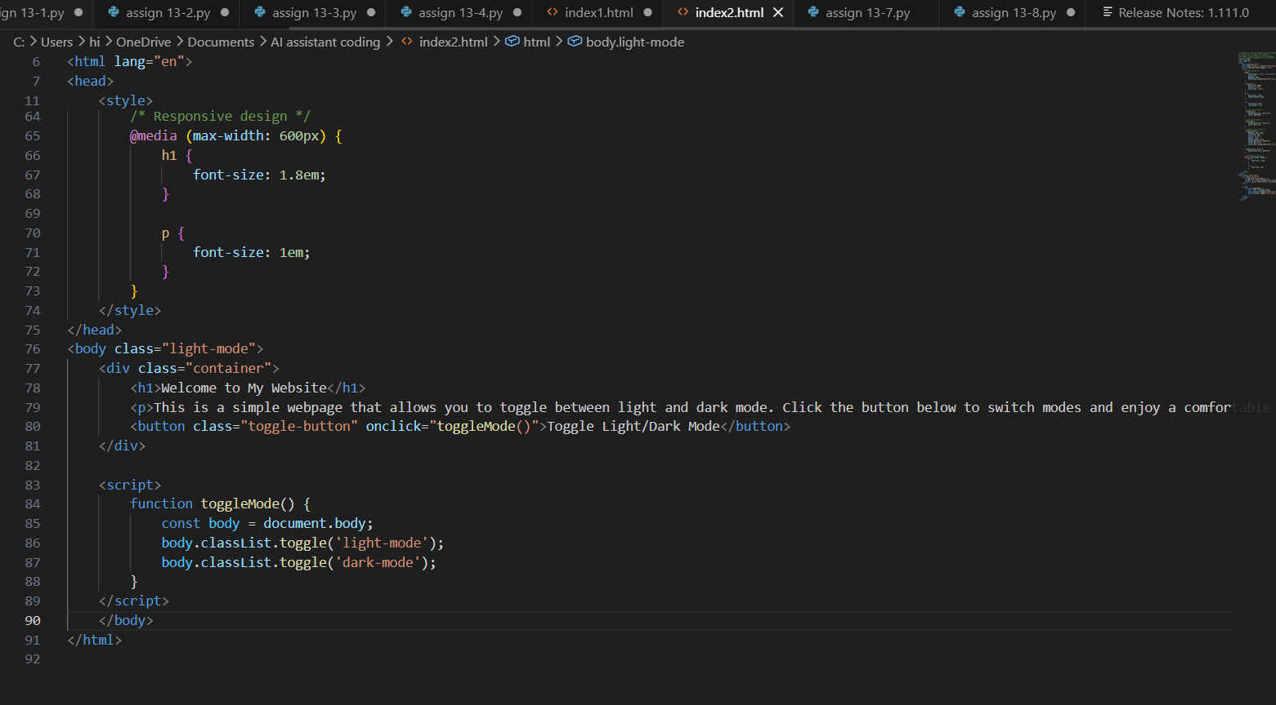

Output:
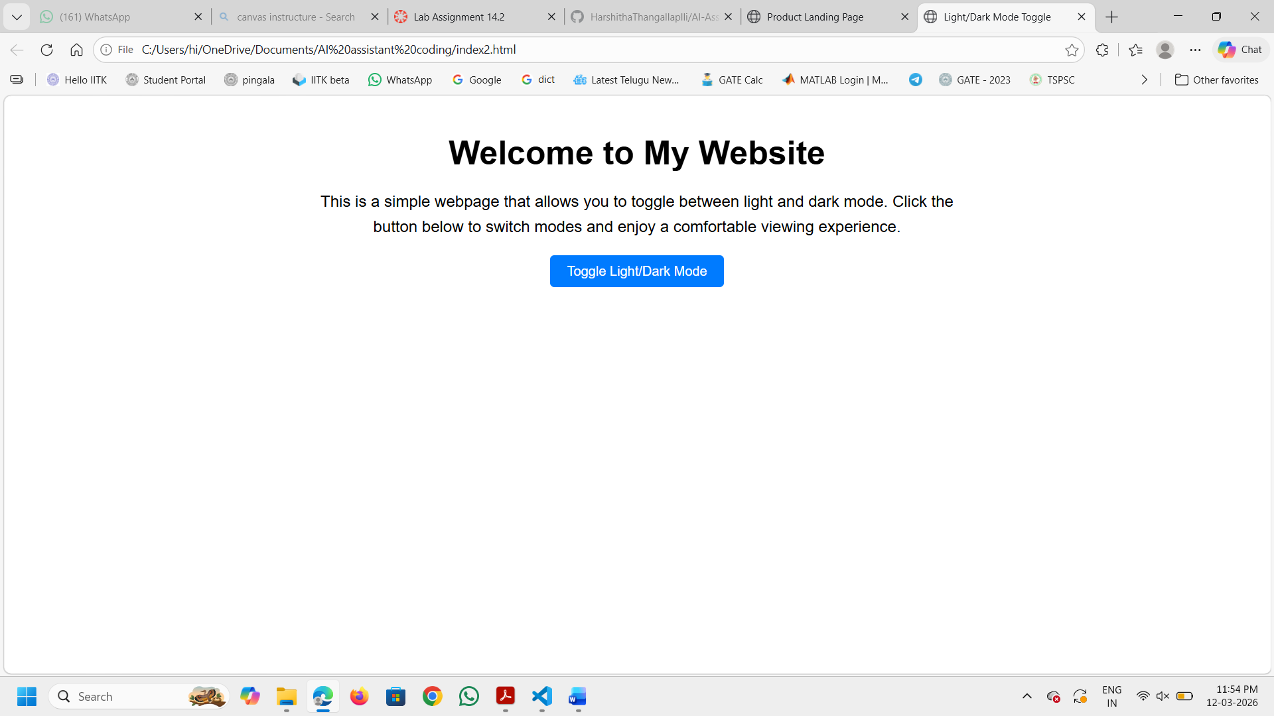
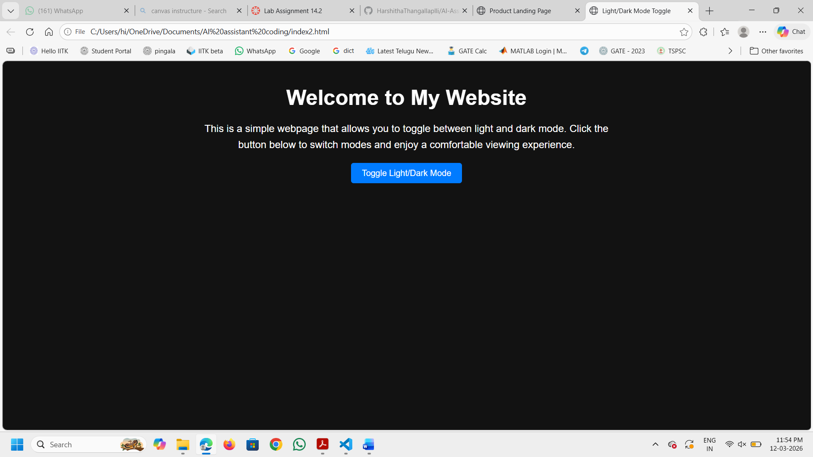

Explanation:
The webpage includes a toggle button that switches between light and dark mode using CSS classes and JavaScript. The layout is responsive, ensuring it looks good on various devices and screen sizes. The typography is chosen for readability, and the color scheme is adjusted for both modes to provide a comfortable viewing experience.

Task Description 3 – (User Feedback Form)
• Create a feedback form with fields: Username, Rating,
Comments.
Requirements:
• Use JavaScript to validate required fields.
• Display success or error messages dynamically.
• Use AI to improve form usability and layout.

Prompt and code:

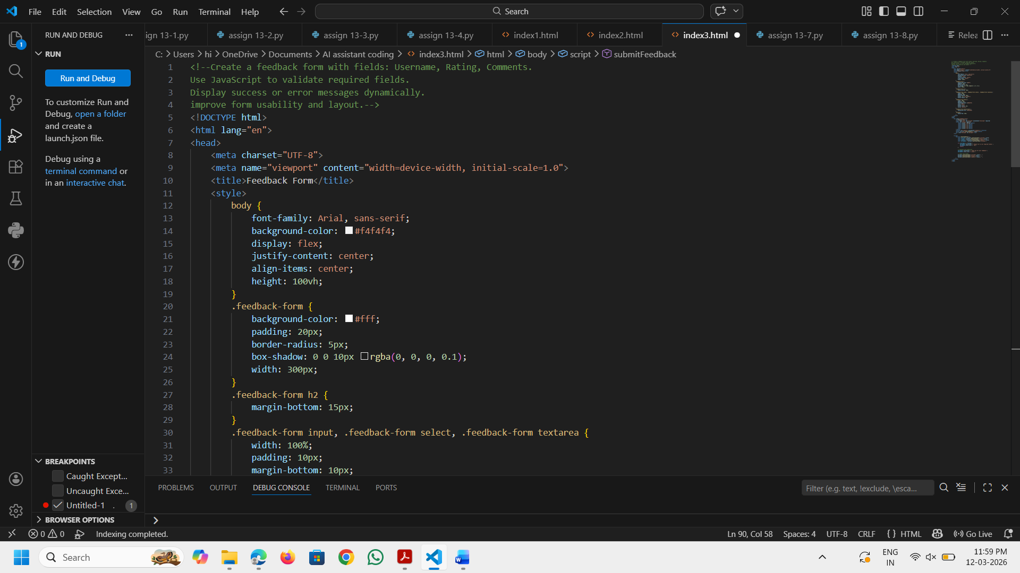

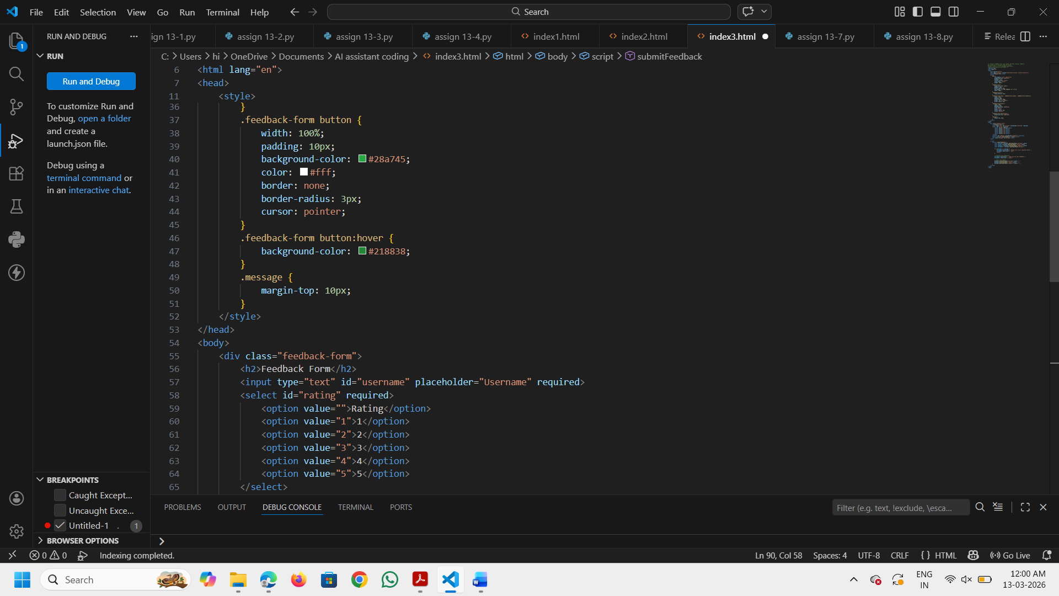
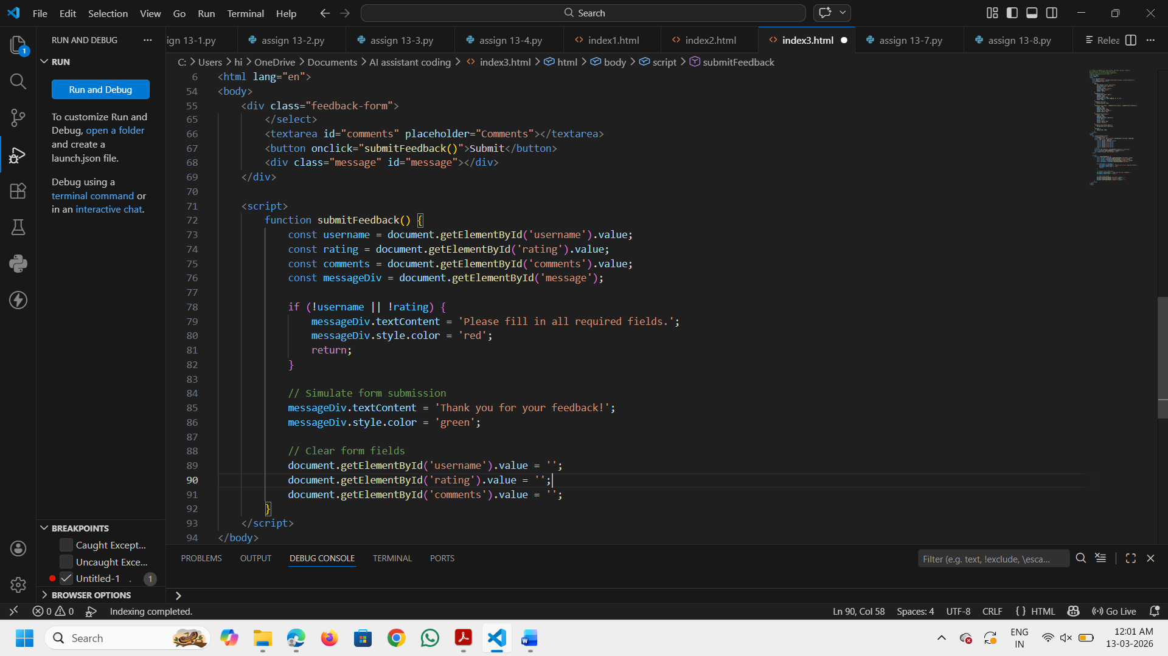

Output:
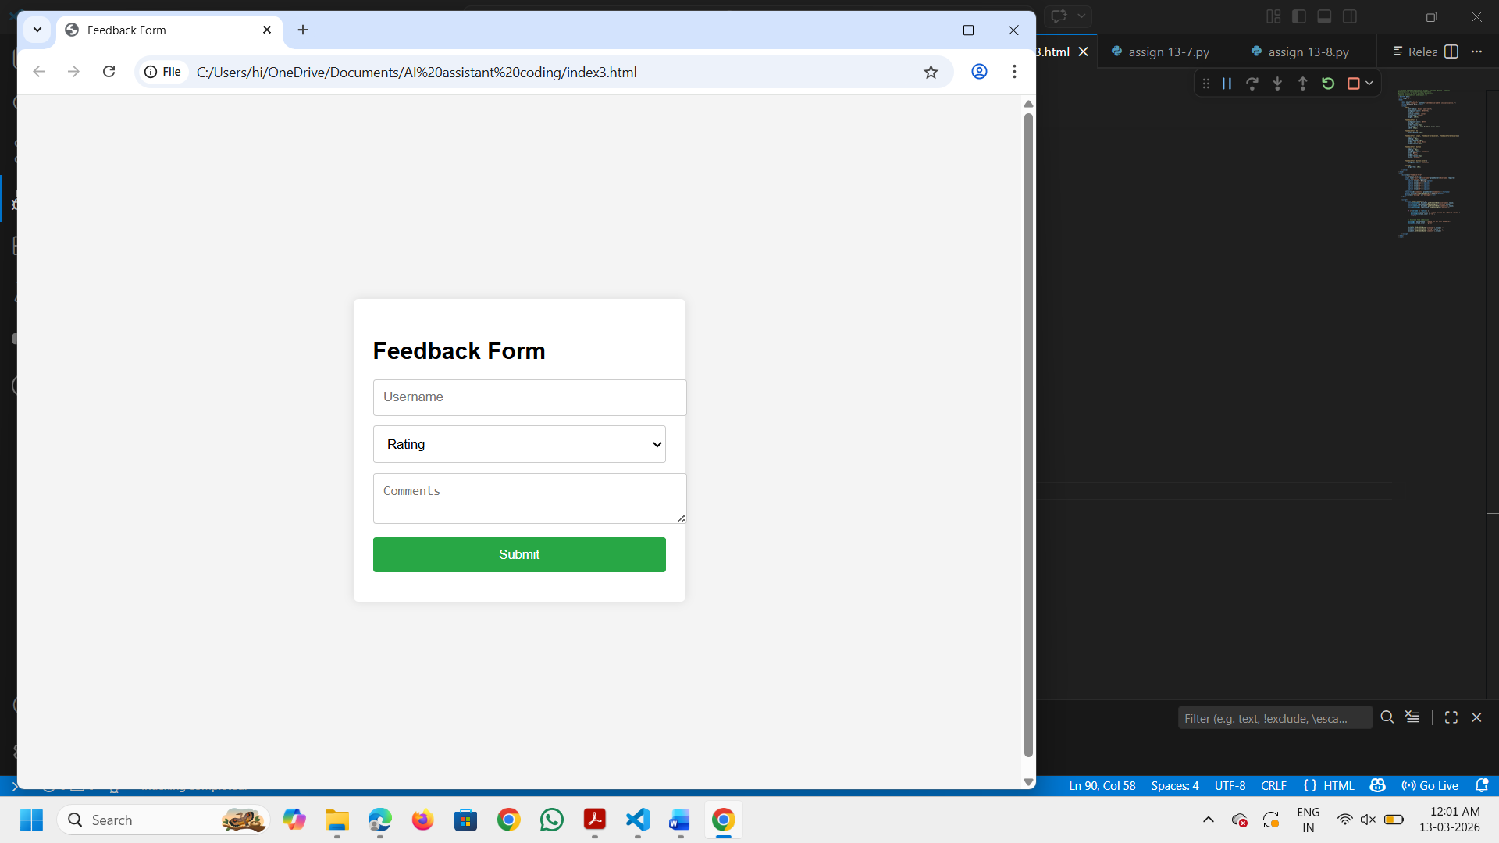
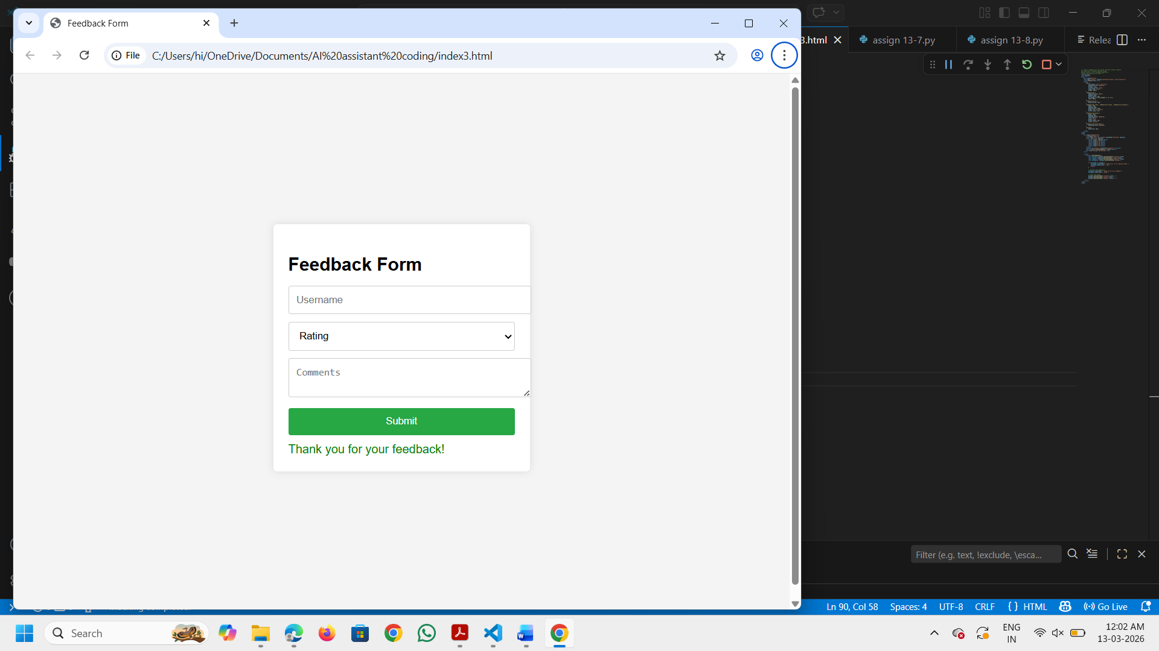
Explanation:
This feedback form includes fields for the user's name, a rating, and comments. JavaScript is used to validate that the required fields are filled out before submission. Success or error messages are displayed dynamically based on the validation results. The layout is designed to be user-friendly and responsive.

Task Description - 4 (Image Gallery with JavaScript)
• Task: Display a small image gallery on a web page.
Requirements:
• Use JavaScript to dynamically load images.
• Add next/previous navigation buttons.
• Use AI to optimize layout responsiveness.

Prompt and Code:
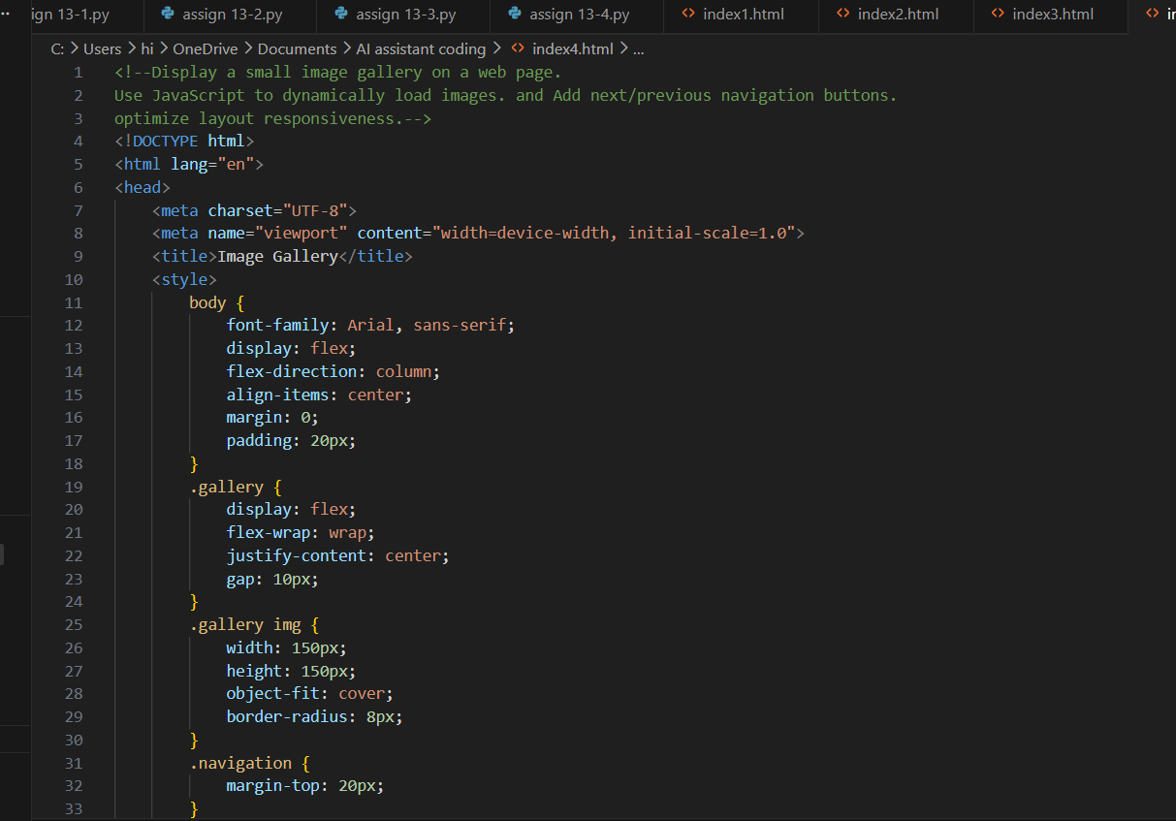
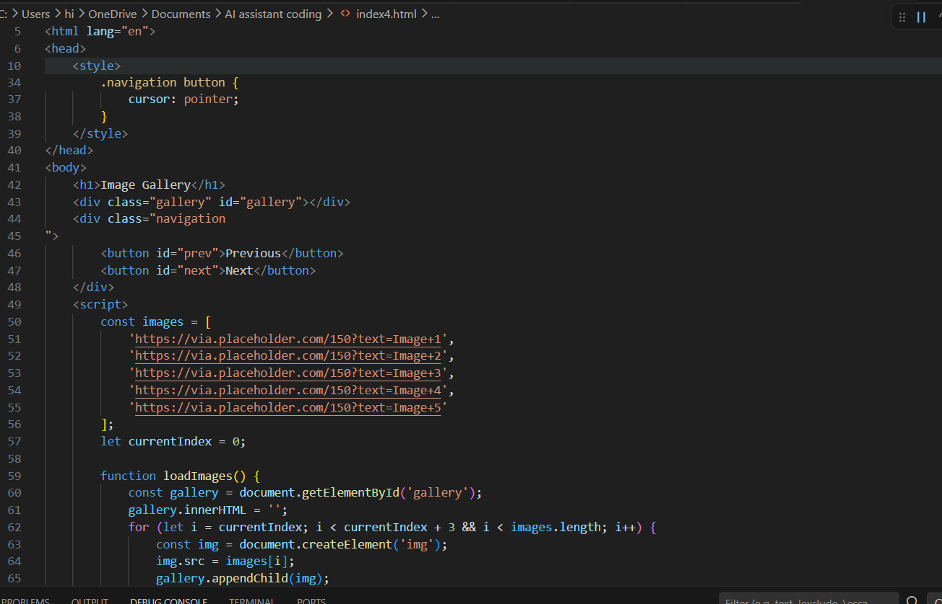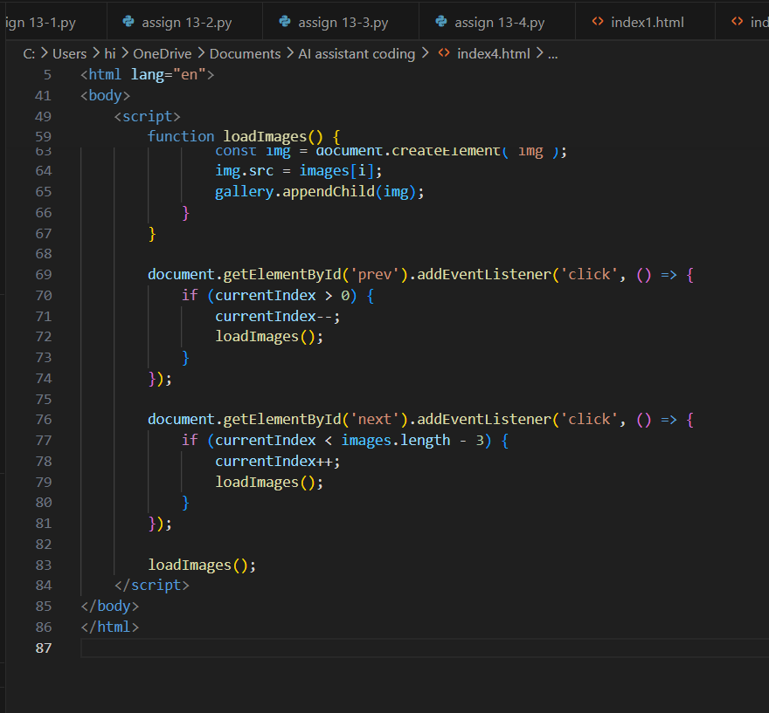

Output:
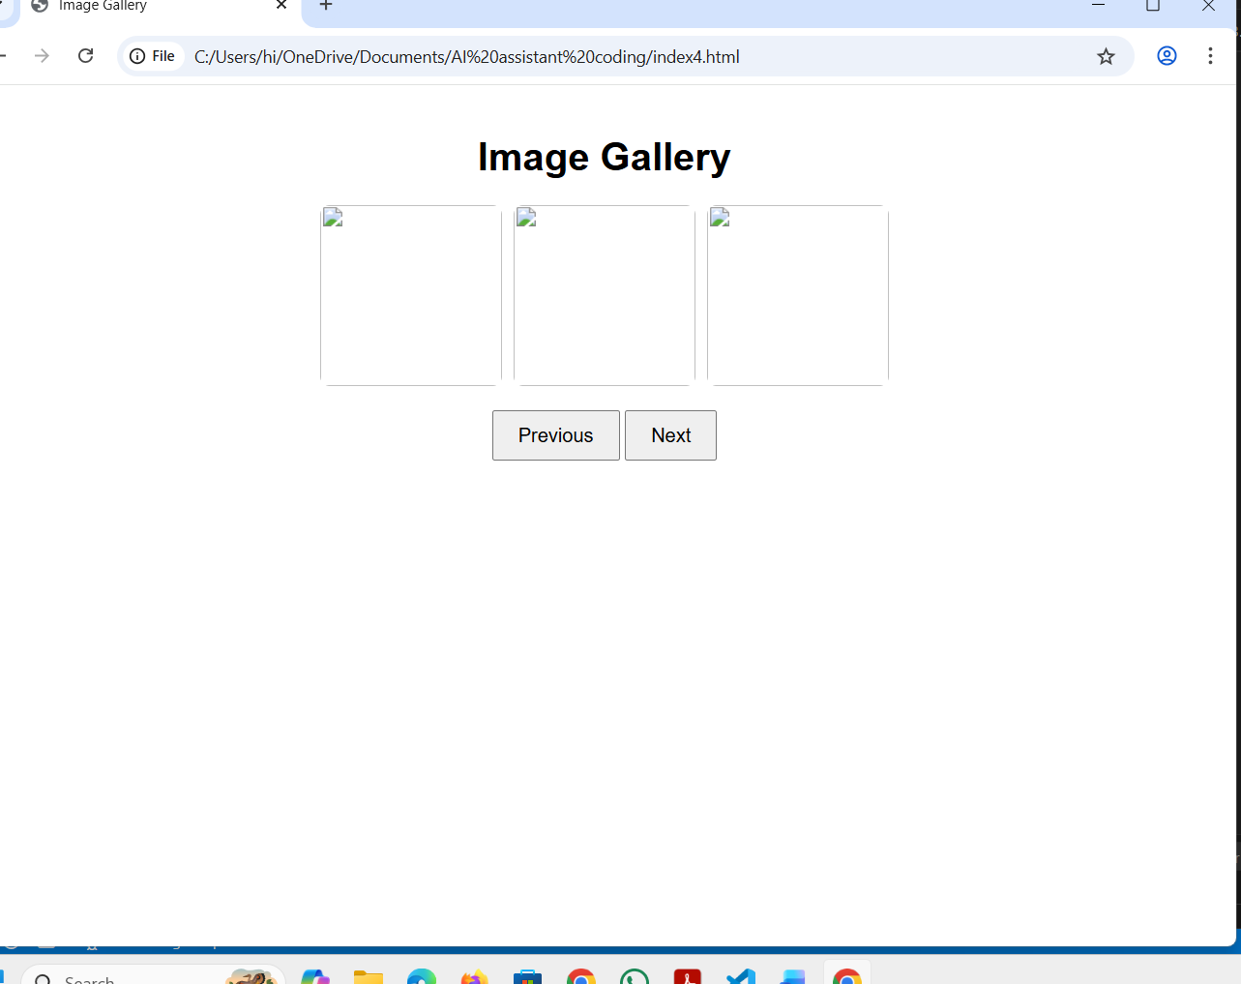
Explanation:
This code creates a simple image gallery with next and previous navigation buttons. The gallery displays three images at a time, and the user can navigate through the images using the buttons. The JavaScript dynamically loads the images based on the current index, ensuring that the layout remains responsive and user-friendly. The CSS styles ensure that the images are displayed in a neat grid with appropriate spacing and styling.

Task Description - 5: (Notification Banner)
• Display a notification banner at the top of the page.
Requirements:
• Use JavaScript to show and hide the banner.
• Style the banner using CSS.
• Use AI to ensure smooth transitions and clean UI behavior.

Prompt and Code:
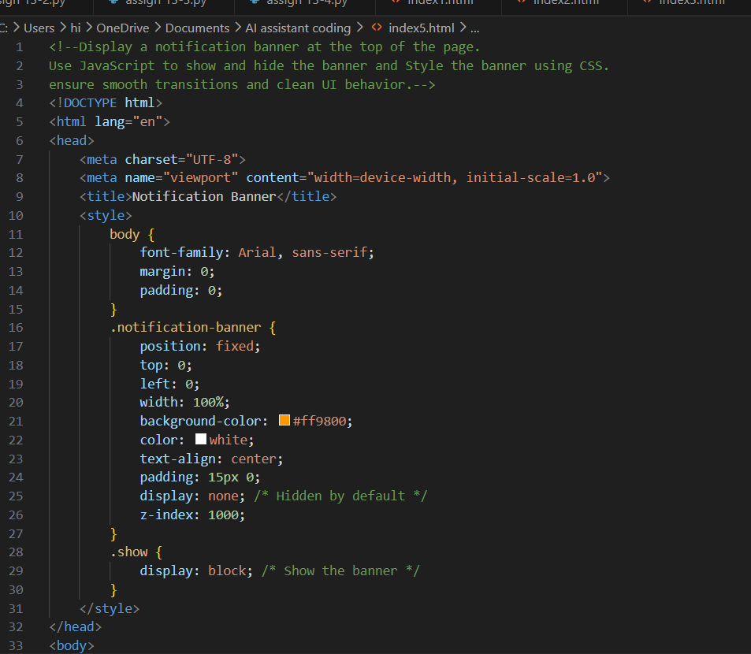
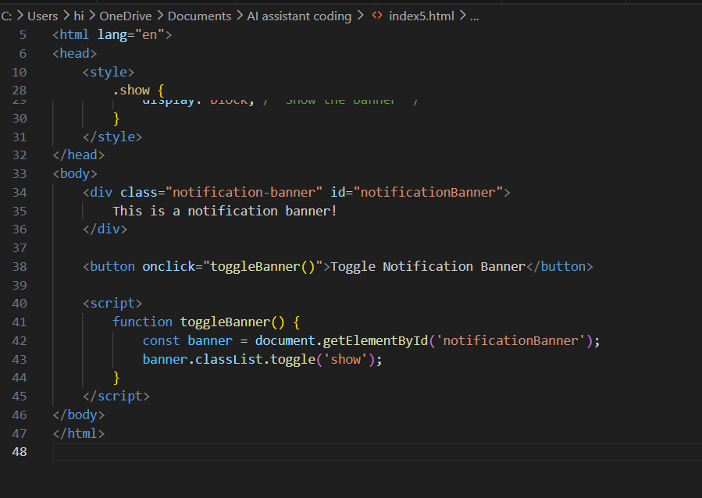
Output:
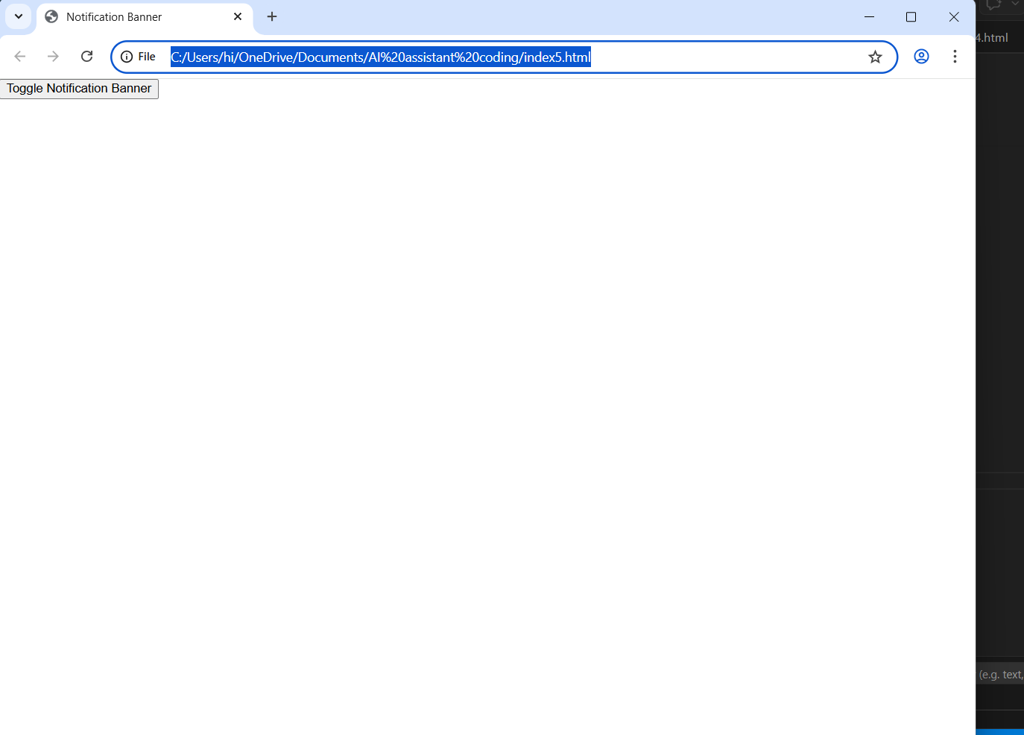
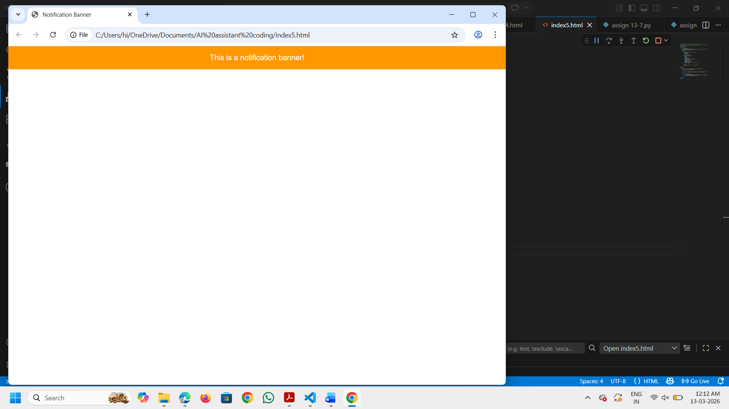

Explanation:
This code creates a notification banner that can be toggled on and off using a button. The banner is styled with CSS to be fixed at the top of the page, with a bright background color and white text for visibility. The JavaScript function `toggleBanner` uses the `classList.toggle` method to add or remove the 'show' class, which controls the visibility of the banner. This allows for smooth transitions and a clean user interface when showing or hiding the notification.

